Router(config)#

Router(config)#ip route 192.10.39.0 255.255.255.128 192.10.39.145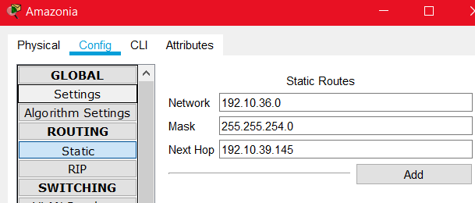

Router(config)#

Router(config)#ip route 192.10.24.0 255.255.248.0 192.10.39.149

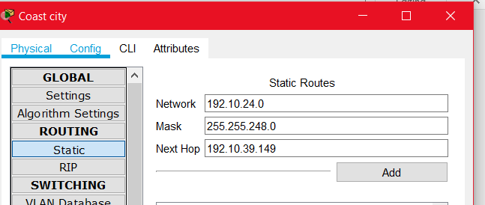

Router(config)#

Router(config)#ip route 192.10.36.0 255.255.254.0 192.10.39.145

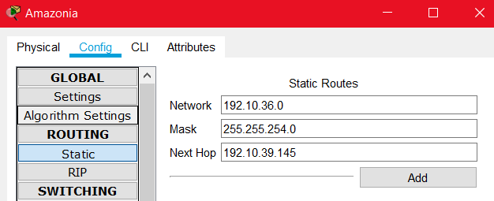

Router(config)#ip route 192.10.24.0 255.255.248.0 192.10.39.138

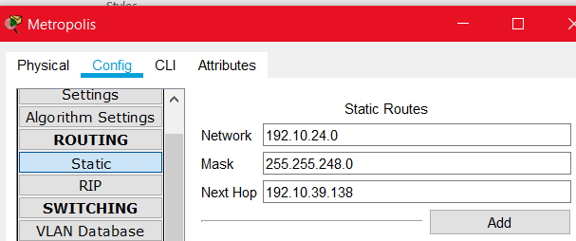

Router(config)#ip route 192.10.38.0 255.255.255.0 192.10.39.145

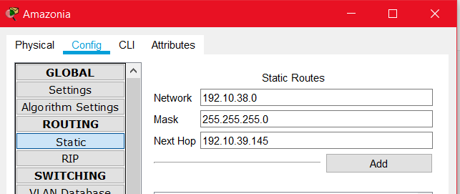

Router(config)#

Router(config)#ip route 192.10.24.0 255.255.248.0 192.10.39.134

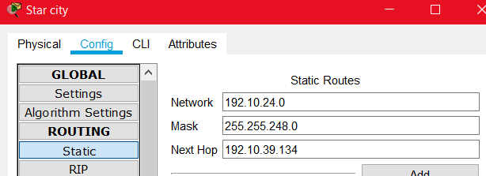

Backup ROUTE AMAZONIA TO COAST CITY

Router(config)#ip route 192.10.39.0 255.255.255.128 192.10.39.153 11

COAST CITY TO AMAZONIA

Router(config)#ip route 192.10.24.0 255.255.248.0 192.10.39.154 11

Backup route from Amazonia to Metropolis

Router(config)#ip route 192.10.36.0 255.255.255.128 192.10.39.153 12

Backup route from Metropolis to Amazonia

Router(config)#ip route 192.10.24.0 255.255.248.0 192.10.39.138 12

Backup Route from Star City to Amazonia

Router(config)#ip route 192.10.24.0 255.255.248.0 192.10.39.130 13

Backup Route from Amazonia to Star City

Router(config)#ip route 192.10.38.0 255.255.255.0 192.10.39.153 13

Atlantis to Coast City Static Route

Router(config)#ip route 192.10.39.0 255.255.255.128 192.10.39.141

Coast city to atlantis static routing

Router(config)#ip route 192.10.8.0 255.255.248.0 192.10.39.149

Atlantis and Coast City Floating Static Route-

Router(config)#ip route 192.10.39.0 255.255.255.128 192.10.39.141 15

Coast City to Atlantis Floating Static Route-

Router(config)#ip route 192.10.8.0 255.255.248.0 192.10.39.149 15

Atlantis and Metropolis Floating static route

Router(config)#ip route 192.0.36.0 255.255.254.0 192.10.39.141

Metropolis to Atlantis Floating Static Route

Router(config)#ip route 192.10.8.0 255.255.248.0 192.10.39.138

Atlantis to Star city

Router(config)#ip route 192.10.38.0 255.255.255.0 192.10.39.141 17

Star City to Atlantis

Router(config)#ip route 192.10.8.0 255.255.248.0 192.10.39.134 17